Part 1
Section A

Team Roles: Kamvelihle Athabile Dyantyi serves as the Full-Stack Developer, Scrum Master, and Product Owner.
Agile Collaboration Explanation: This Azure Boards setup reflects real-world agile collaboration by establishing a single source of truth for the project lifecycle. Defining explicit Area Paths (e.g., Volunteer Management, Donation Tracking) compartmentalizes the application into manageable business domains. Establishing Iteration Paths (Sprints) enforces strict timeboxing. Operating as a solo developer utilizing AI pair-programming agents, this rigid structure ensures personal accountability, prevents scope creep, and perfectly mimics industry-standard enterprise planning environments.
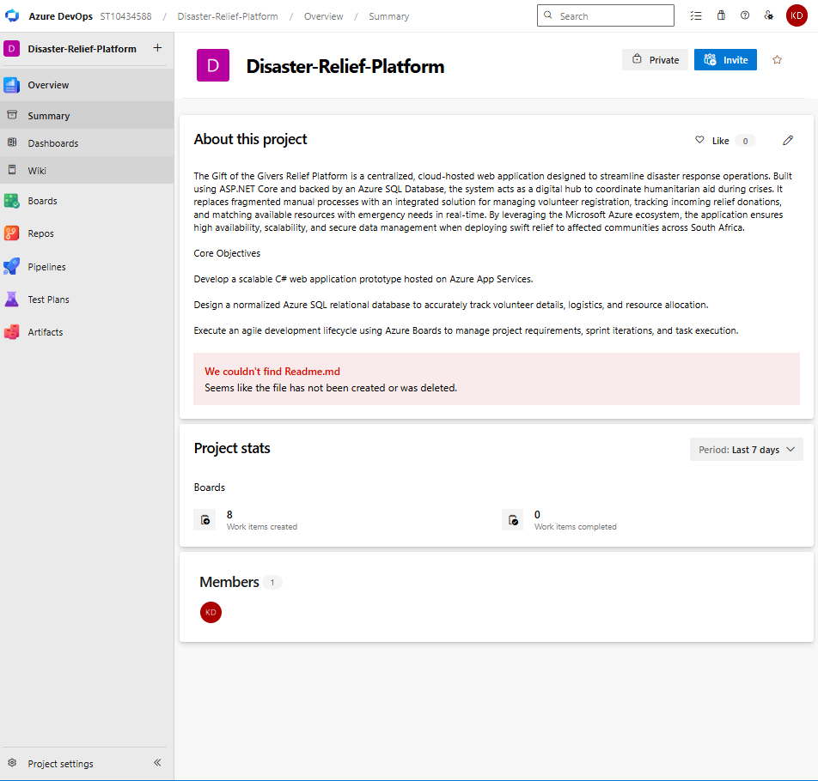
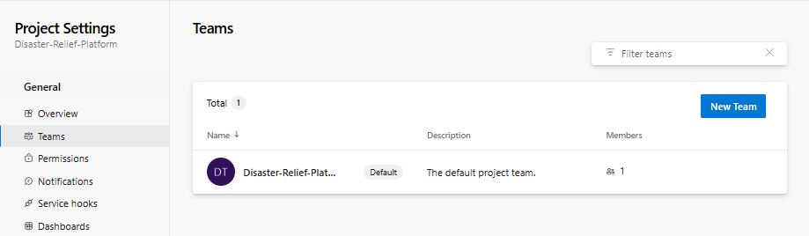
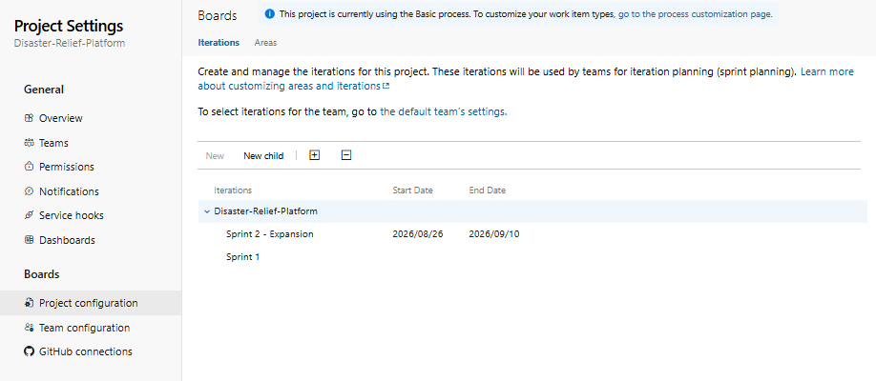
1.2
Requirements structure rationale: The backlog is structures hierarchically to break the broad distater relief vision into executable engineering units.
Epics : act as the large building blocks categorizing major modules like volunteer management
Users Stories(example ("As a relief coordinator, I want to register new volunteers...") ensure the development remains user-centric, focusing on the practical value delivered to the Gift of the Givers Foundation rather than just writing disconnected code).
Tasks translate those uer-centric needs into highly granular , technical development activities (e.g., designing the Azure SQL tables and building the ASP.NET UI) that can be actively tracked across the Kanban board.
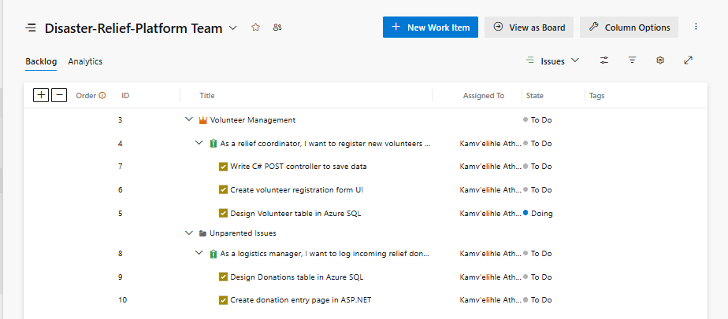
1.3
Sprint 1 (The protoype) Goal : Establish the core application architecture and deliver a foundational, working prototype specifically for the volunteer management module
Sprint 1 Deliverables : A deployed ASP.NET core web application connected to an Azure Sql Database , deaturing a fully functional data entry form to register and save volunteer contact details.
Future Sprints(Expansion): Sprint 2 will introduce the Dontation Tracting Epic. It will expand the foundations database schema to handle emergency inventory and add resource allocation views to the existing web application, scaling the prototype into a comprehensive distaster response hub.
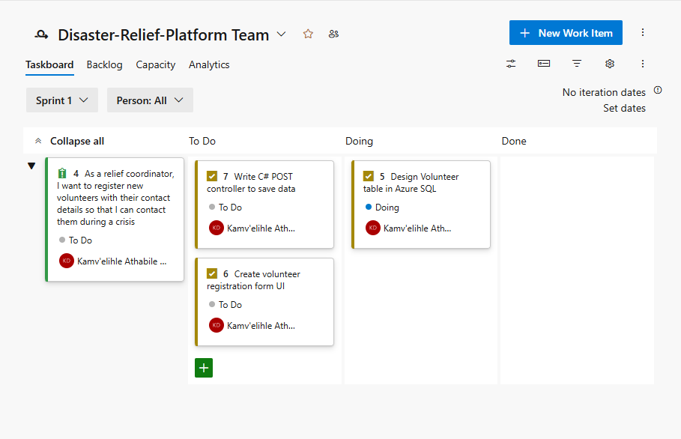

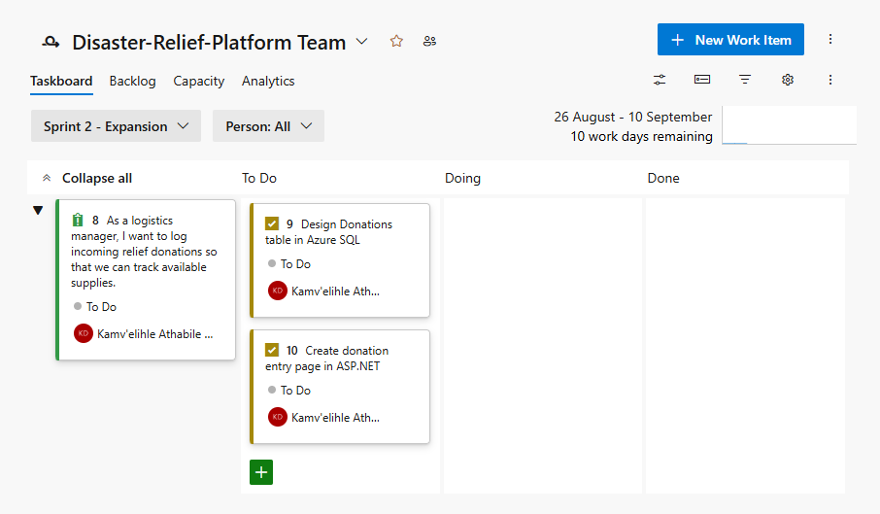

Section B
2.1
2.2
Data Dictionary
Table Name | Column Name | Data Type | Constraints | Description
SeverityLevels | SeverityID | INT | PK, IDENTITY(1,1) | Unique identifier for severity classifications.
SeverityLevels | SeverityName | NVARCHAR(50) | UNIQUE, NOT NULL | Impact classification (e.g., Low, Critical).
DisasterStatuses | StatusID | INT | PK, IDENTITY(1,1) | Unique identifier for operational statuses.
DisasterStatuses | StatusName | NVARCHAR(50) | UNIQUE, NOT NULL | Operational status (e.g., Active, Resolved).
Skills | SkillID | INT | PK, IDENTITY(1,1) | Unique identifier for a specific skill.
Skills | SkillName | NVARCHAR(100) | UNIQUE, NOT NULL | Name of the qualification (e.g., First Aid).
ItemTypes | ItemTypeID | INT | PK, IDENTITY(1,1) | Unique identifier for donation categories.
ItemTypes | TypeName | NVARCHAR(100) | UNIQUE, NOT NULL | Classification of goods (e.g., Bottled Water).
Disasters | DisasterID | INT | PK, IDENTITY(1,1) | Unique identifier for each disaster event.
Disasters | Title | NVARCHAR(150) | NOT NULL | Descriptive name of the disaster.
Disasters | Location | NVARCHAR(255) | NOT NULL | Geographical location or region affected.
Disasters | SeverityID | INT | FK, NOT NULL | Links to SeverityLevels.
Disasters | StatusID | INT | FK, NOT NULL | Links to DisasterStatuses.
Disasters | DateReported | DATETIME2 | DEFAULT SYSUTCDATETIME | UTC timestamp of when the disaster was logged.
Volunteers | VolunteerID | INT | PK, IDENTITY(1,1) | Unique identifier for each registered volunteer.
Volunteers | FirstName | NVARCHAR(100) | NOT NULL | The volunteer's legal first name.
Volunteers | LastName | NVARCHAR(100) | NOT NULL | The volunteer's legal last name.
Volunteers | EmailAddress | NVARCHAR(150) | UNIQUE, NOT NULL | Contact email; unique for system login purposes.
Volunteers | PhoneNumber | NVARCHAR(20) | NOT NULL | Primary mobile contact number.
Volunteers | IsAvailable | BIT | DEFAULT 1 | Boolean flag for deployment readiness (1=True).
VolunteerSkills | VolunteerID | INT | PK, FK, NOT NULL | Links to Volunteers. Cascades on delete.
VolunteerSkills | SkillID | INT | PK, FK, NOT NULL | Links to Skills. Cascades on delete.
Donations | DonationID | INT | PK, IDENTITY(1,1) | Unique identifier for each incoming donation batch.
Donations | ItemTypeID | INT | FK, NOT NULL | Links to ItemTypes to enforce valid goods categories.
Donations | Quantity | INT | NOT NULL, CHECK > 0 | Numeric amount received. Cannot be zero or negative.
Donations | DateReceived | DATETIME2 | DEFAULT SYSUTCDATETIME | UTC timestamp of warehouse entry.
Donations | AllocatedDisasterID | INT | FK, NULL

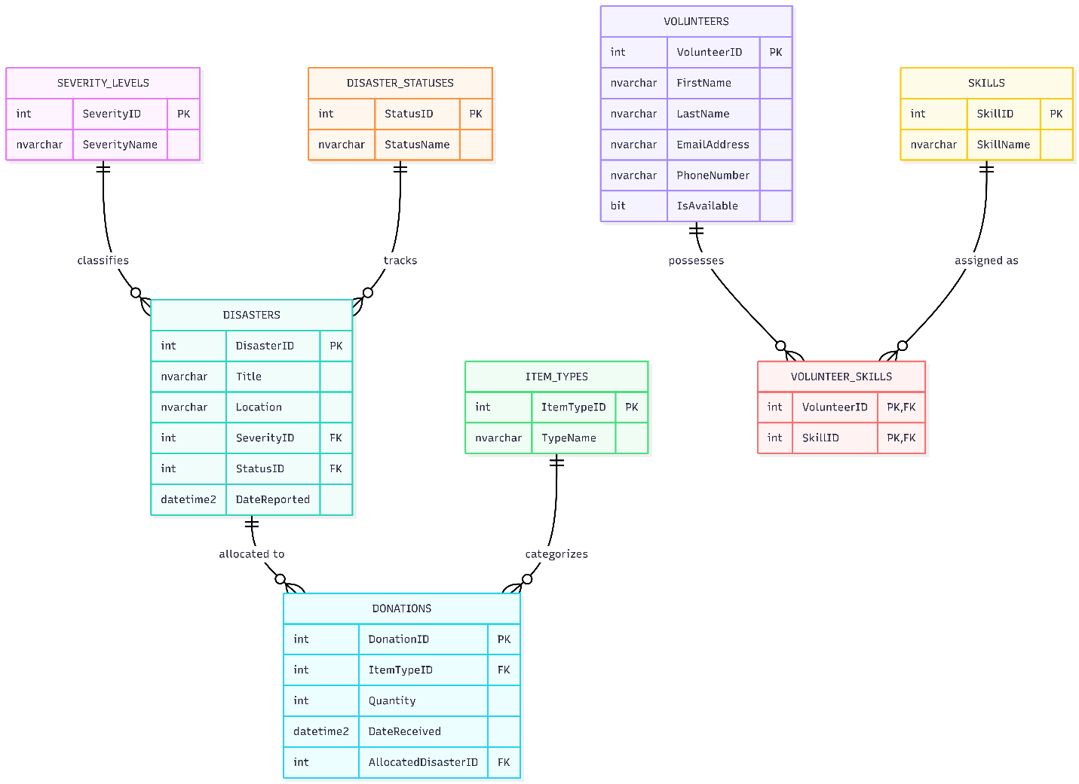
2.3
1. Priming the Agent for Future Code Your Gem needs to "memorize" your database. When you move to the next phase of development and need to write the C# Entity Framework Core models or generate a complex SQL query to join the Volunteers and Donations tables, the agent can only write accurate code if it already knows your exact schema. Feeding it the prompt now sets the foundation.
2. Generating Real Proof for Your POE Since you are explicitly doing this project solo and claiming you used AI agents as your pair-programming team, your lecturer might ask to see evidence of your prompts or chat history. Having this conversation logged in your Gemini Advanced account gives you a paper trail showing you actually set up and utilized the agent as an Agile teammate.
2.3 Azure SQL Integration Strategy
- The Strategy: The C# web application will interface with the Azure SQL Database using Entity Framework Core (EF Core) as the Object-Relational Mapper (ORM).
- Best Practices: To ensure secure and scalable cloud connectivity, the application will inject a scoped DbContext. It will use connection resiliency and retry logic built into EF Core to handle transient cloud faults. Furthermore, sensitive connection strings will never be hardcoded in the GitHub repository; they will be strictly managed via Azure App Settings and secured using Managed Identities where applicable.

Section C
3.1 Cloud Hosting & Architecture
- Host Environment: The ASP.NET Core web application is hosted on Azure App Service (Linux) using a basic/free tier (F1/B1) to keep operational overhead at zero while ensuring 99.95% cloud availability.
- Architecture Rationale: A Platform-as-a-Service (PaaS) model abstracts server maintenance, OS patching, and network configuration. This allows development to focus entirely on application logic and rapid disaster relief response rather than infrastructure upkeep.
3.2 Automated CI/CD Pipeline (GitHub Actions)
- Pipeline Flow: Continuous Integration and Continuous Deployment (CI/CD) is automated using GitHub Actions targeting the Azure App Service publish profile.
- Build Stage: Every push or pull request merged into the main branch triggers an automated build workflow that restores NuGet packages, compiles the C# codebase, and runs automated unit tests.
- Deploy Stage: Upon successful compilation and test execution, the pipeline packages the build artifact and deploys it directly to the staging/production slot on Azure App Service with zero manual intervention.
3.3 Configuration & Secrets Management
- Security Protocol: Database connection strings and external API credentials are strictly excluded from source control (appsettings.json excludes sensitive production values).
- Runtime Injection: The Azure SQL connection string is stored securely within Azure App Service Configuration (Environment Variables / Connection Strings) and injected into the ASP.NET Core application runtime via Dependency Injection at startup.
3.4 Monitoring & Telemetry
- Application Insights: Azure Application Insights is integrated into the App Service to monitor request response rates, detect HTTP 5xx runtime errors, and track SQL query performance bottlenecks in real-time during peak relief traffic.

